AP Review – Sensation and Perception

Sensation and Perception (6–8%)

Everything that organisms know about the world is first encountered when stimuli in the environment activate sensory organs, initiating awareness of the external world. Perception involves the interpretation of the sensory inputs as a cognitive process. AP students in psychology should be able to do the following:
• Discuss basic principles of sensory transduction, including absolute threshold, difference threshold, signal detection, and sensory adaptation.
• Describe sensory processes (e.g., hearing, vision, touch, taste, smell, vestibular, kinesthesis, pain), including the specific nature of energy transduction, relevant anatomical structures, and specialized pathways in the brain for each of the senses.
• Explain common sensory disorders (e.g., visual and hearing impairments).
• Describe general principles of organizing and integrating sensation to promote stable awareness of the external world (e.g., Gestalt principles, depth perception).
• Discuss how experience and culture can influence perceptual processes (e.g., perceptual set, context effects).
• Explain the role of top-down processing in producing vulnerability to illusion.
• Discuss the role of attention in behavior.
• Challenge common beliefs in parapsychological phenomena.
• Identify the major historical figures in sensation and perception (e.g., Gustav Fechner, David Hubel, Ernst Weber, Torsten Wiesel)

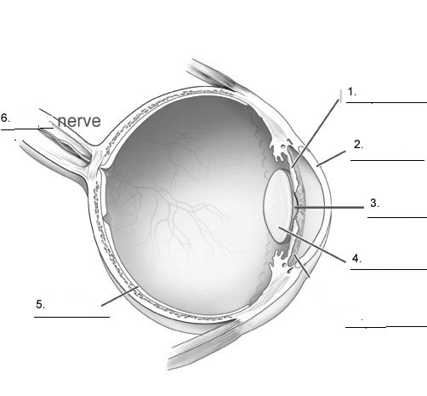

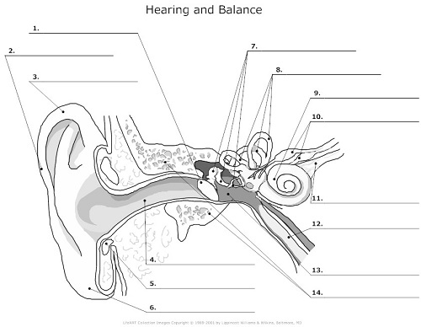
Term | Definition
Absolute Threshold
Sensory Adaptation
Transduction
Signal Detection Theory
Gate-Control Theory
Rods
Cones
Blind-Spot
Bipolar Cells
Ganglion Cells

Trichromatic Theory
Opponent-Process Theory
Cochlea
Pitch
Frequency Theory
Place Theory
Conduction Deafnesss
Nerve deafness
Olefactory Bulb
Papillae
Kinesthetic senses
Vestibular senses
Figure Ground relationship
Perceptual Grouping

Monocular Depth Cues
Binocular Depth Cues

Figure | Perspective | Research/Theory
Ernst Heinrich Weber
Gustov Fechner
David Hubel
Torsten Wiesel
Eleanor Gibson

