Chapter 9:
Memory

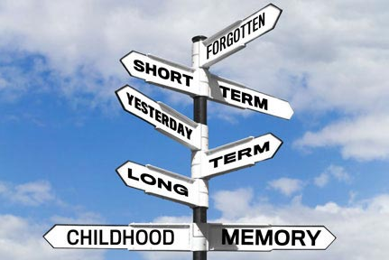

AP Psychology
Mrs. Wilson
Assignment | Due Date
Read 349-353
Read 353-361
Read 361-370
Read 370-375
Read 375-381
Read 382-390
Read 391-392

Name ___________________________

Period _____

Cognition (8–10%)
Incorporates material in chapters on Memory and Thinking and Language. Bold indicates concepts from Chapter 8: Memory

In this unit students learn how humans convert sensory input into kinds of information. They examine how humans learn, remember, and retrieve information. This part of the course also addresses problem solving, language, and creativity.

AP students in psychology should be able to do the following:
- Compare and contrast various cognitive processes:
  - effortful versus automatic processing;
  - deep versus shallow processing;
  - focused versus divided attention.
- Describe and differentiate psychological and physiological systems of memory
  - Short-term memory
  - Long-term memory
  - Implicit memory
  - Explicit memory
  - Long-term potentiation
  - Stress hormones and impact on memory
  - Role of hippocampus and cerebellum in memory formation
  - Moods and memory
- Thoroughly explain effective encoding, storage, and retrieval (use pictures in your explanation).
- Discuss construction of memories (include an example of each).
  - Misinformation and imagination effect
  - Source amnesia
  - Eyewitness testimony
  - Repression
- Describe strategies for memory improvement.
- Explain how the following factors converge to facilitate acquisition, development, and use of language.
  - Biological factors,
  - Cognitive factors,
  - and cultural factors
- Identify problem-solving strategies as well as factors that influence their effectiveness.
- List the characteristics of creative thought and creative thinkers.
- Make a chart to identify the major figures in the psychology of cognition using the following columns (Who, What, When, Where and Why)
  - Noam Chomsky,
  - Hermann Ebbinghaus,
  - Wolfgang Köhler,
  - Elizabeth Loftus,
  - George A. Miller

Key Terms and Figures

Terms

- Memory
- Encoding
- Storage
- Retrieval
- Sensory Memory
- Short Term Memory
- Long Term Memory
- Working Memory
- Automatic Processing
- Effortful Processing
- Rehearsal
- Spacing Effect
- Serial Position
- Visual Encoding
- Acoustic Encoding
- Semantic Encoding
- Imagery
- Mnemonics
- Chunking
- Iconic Memory
- Echoic Memory
- Long Term Potentation
- Flashbulb Memory
- Amnesia
- Implicit Memory
- Explicit Memory
- Hippocampus
- Recall
- Recognition
- Relearning
- Priming
- Déjà vu
- Mood-Congruent Memory
- Proactive Interference
- Retroactive Interference
- Repression
- Misinformation Effect
- Source Amnesia

Names
- Noam Chomsky
- Hermann Ebbinghaus
- Elizabeth Loftus

KEY TERMS DUE AT TEST

FACT OR FALSEHOOD

T F 1. Memory storage is never automatic; it always takes effort.
T F 2. When people go around a circle saying their names, their poorest memories are for what was
said by the person just before them.
T F 3. Memory aids (for example, those that use imagery and devices for organization) are no more
useful than simple rehearsal of information.
T F 4. Only a few people have any type of photographic memory.
T F 5. Although our capacity for storing information is large, we are still limited in the number of
permanent memories we can form.
T F 6. Our experiences are etched on our brain, just as the grooves on a tape receive and retain
recorded messages.
T F 7. When people learn something while intoxicated, they recall it best when they are again
intoxicated.
T F 8. The hour before sleep is a good time to commit information to memory.
T F 9. How confident eyewitnesses are about what they saw is an important predictor of their
accuracy.
T F 10. Children typically will repress any memory of having seen one of their parents being murdered.

Remembering the Seven Dwarfs

- ___________________________________________
- ___________________________________________
- ___________________________________________
- ___________________________________________
- ___________________________________________
- ___________________________________________
- ___________________________________________

- ___________________________________________
- ___________________________________________
- ___________________________________________
- ___________________________________________
- ___________________________________________
- ___________________________________________
- ___________________________________________

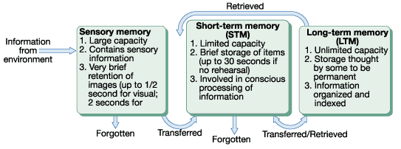

What are Memories?
- Hippocampus
- ACH & Serotonin
- Frontal Lobe
- Amygdala

Brain Based
ENCODING

Primacy
Recency
Antero-grade
Retro-grade
Psychogenic
Proactive
Retroactive
Interference
- Cues
  - Mood/State Dep.
  - Context
Amnesia
Serial position
Forget
Retrieval Failure
RETRIEVAL
Remember
Retrieval Success
- Explicit/declarative
- Implicit/Non-declarative

LTM
Hard Drive
STORAGE
STM
Temporary Files

Sensory system
- Iconic-Eidetic
- Echoic
- Haptic
- Decays in 1-2 sec.
- Episodic (flashbulb)
- Semantic
- Procedural
- Deeply Processed
- Visual Retention
- Auditory Imprint
- Tactile/Kinesthetic
- Shallow Processing
- 7±2 Chunk – 20-30 sec

