Ch. 5 & 6:
Sensation and Perception

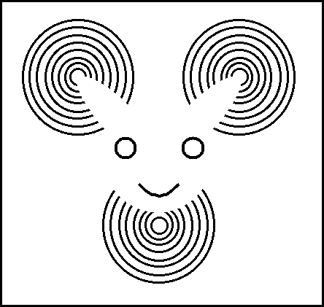

AP Psychology
Mrs. Wilson
Assignment | Due Date
Read 197-203
Read 204-211
Read 212-214
Read 215-223
Read 224-234
Read 234-237
Read 237-242
Read 242-253
Read 254-263
Read 264-268

Name ___________________________

Period _____

Sensation and Perception (6–8%)
Everything that organisms know about the world is first encountered when stimuli in the environment activate sensory organs, initiating awareness of the external world. Perception involves the interpretation of the sensory inputs as a cognitive process.

AP students in psychology should be able to do the following:

1. Explain basic principles of sensory transduction, including:
a. absolute threshold,
b. difference threshold,
c. signal detection, and
d. sensory adaptation.
2. Describe sensory processes, including
a. the specific nature of energy transduction for each of the senses,
b. relevant anatomical structures for each of the senses,
c. and specialized pathways in the brain for each of the senses

(e.g., hearing, vision, touch, taste, smell, vestibular, kinesthesis, pain).
3. Explain common sensory disorders (e.g., deafness, phantom limb, etc.)
4. Describe and contrast general principles of organizing and integrating sensation to promote stable awareness of the external world
a. depth perception
i. monocular cues
ii. binocular cues
b. Gestalt principles
i. proximity,
ii. similarity,
iii. figure-ground,
iv. closure,
v. continuation
5. Explain how experience and culture can influence perceptual processes (e.g., perceptual set, context effects, etc.).
6. Explain the role of top-down processing in producing vulnerability to illusion.
7. Describe the role of attention in behavior.
8. Explain and challenge common beliefs in parapsychological phenomena (e.g., precognition, etc.).
9. Identify the major historical figures in sensation and perception (What, When, Where and Why)
a. Gustav Fechner,
b. David Hubel,
c. Ernst Weber,
d. Torsten Wiesel
Key Terms and Figures

Terms

- Sensation
- Perception
- Bottom-Up processing
- Top-Down processing
- Psychophysics
- Absolute thresholds
- Signal detection theory
- Subliminal
- Prime
- Difference threshold
- Weber’s Law
- Adaptation
- Transduction
- Wavelength
- Intensity
- Hue
- Pupil
- Iris
- Lens
- Accommodation
- Retina
- Acuity
- Nearsightedness
- Farsightedness
- Rods
- Cones
- Optic nerve
- Blind spot
- Fovea
- Feature detector
- Parallel processing
- Young-Helmholtz trichromatic theory
- Opponent-process theory
- Color constancy
- Audition
- Frequency
- Pitch
- Middle ear
- Inner ear
- Cochlea
- Place theory
- Frequency theory
- Conduction hearing loss
- Sensorineural hearing loss
- Cochlear implant
- Gate control theory
- Chemical senses
- Sensory interaction
- Kinesthesis
- Vestibular Sense
- Selective attention
- Inattentional blindness
- Visual capture
- Gestalt
- Figure-ground
- Grouping (identify all types)
- Depth perception
- Visual cliff
- Binocular cues (identify all types)
- Monocular cues (identify all types)
- Phi phenomenon
- Perceptual constancy (Id all types)
- Perceptual adaptation
- Perceptual set
- Human factor psychology
- ESP
- Parapsychology
- Precognition

Names

- Gustav Fechner,
- David Hubel,
- Ernst Weber,
- Torsten Wiesel

KEY TERMS DUE AT TEST – 40 pts

Beware of What You Wish For

Human beings do not have the most sensitive or acute sensory systems in the animal world. Some bats can hear frequencies that exceed 100,000 Hertz, dolphins receive auditory messages from great distances, and cats can probably localize sounds better than we do because they can rotate their ears. Rats see better at night than we can, eagles have more acute distance vision, and horses have a wider visual field. Rabbits have more taste buds than we do, and many animals have a keener sense of smell. This exercise asks you to consider how you would perceive the world if your senses were more acute or sensitive than they actually
are.

- List a few things you would see, that you cannot see now, if your sense of vision were “better.”

- List a few things you would hear, that you cannot hear now, if you could hear “better.”

- If your The Other Senses—taste and smell—were more sensitive, how might you be affected?

- Why are our senses no more and no less acute or sensitive than they are?

- If human beings continue to be urban creatures for the next few million years, in what
ways might our sensory systems evolve or change?

