Chapter 4
Developing Through the Life Span

AP Psychology
Mrs. Wilson
Assignment | Due Date
Read 139-146
Read 147-154
Read 154-163
Read 164-175
Read 175-184
Read 185-194

Name ___________________________

Period _____

Developmental Psychology (7–9%)
Developmental psychology deals with the behavior of organisms from conception to death and examines the processes that contribute to behavioral change throughout the life span. The major areas of emphasis in the course are prenatal development, motor development, socialization, cognitive development, adolescence, and adulthood.
AP students in psychology should be able to do the following:

1. Discuss the interaction of nature and nurture (including cultural variations) in the determination of behavior.
2. Explain the process of conception and gestation, including factors that influence successful fetal development
a. nutrition,
b. illness,
c. substance abuse,
d. etc.
3. Describe normal maturation (stages) of motor skill development.
4. Describe the influence of temperament and other social factors on attachment and appropriate socialization.
5. Explain the maturation of cognitive abilities
a. Piaget’s stages,
b. information processing,
c. etc.
6. Compare and contrast models of moral development (Kohlberg’s and Gilligan’s).
7. Discuss maturational challenges in adolescence, including related family conflicts.
8. Explain the development of decisions related to intimacy as people mature.
9. Discuss the physical and cognitive changes that emerge as people age, including steps that can be taken to maximize function.
10. Describe how sex and gender influence socialization and other aspects of development.
11. Identify key contributors in developmental psychology (What, When, Where and Why)
a. Mary Ainsworth,
b. Albert Bandura,
c. Diana Baumrind,
d. Erik Erikson,
e. Sigmund Freud,
f. Carol Gilligan,
g. Harry Harlow,
h. Lawrence Kohlberg,
i. Konrad Lorenz,
j. Jean Piaget,
k. Lev Vygotsky
Key Terms and Figures

Terms

- Developmental Psychology
- Zygotes
- Embryo
- Teratogens
- Fetal Alcohol Syndrome
- Reflex
- Rooting Reflex
- Habituation
- Maturation
- Schemas
- Assimilate
- Accommodate
- Object Perminance
- Egocentrism
- Theory of Mind
- Stranger Anxiety
- Separation Anxiety
- Attachment
- Critical Period
- Imprinting
- Basic Trust
- Self-concept
- Adolescence
- Puberty
- Primary Sex Characteristic
- Secondary Sex Characteristics
- Menarche
- Identity
- Intimacy
- Menopause
- Alzheimer’s
- Crystalized Intelligence
- Fluid Intelligence
- Midlife Crisis
- Social Clock
- Continuity
- Stage Theory

Names

- Mary Ainsworth
- Diana Baumrind
- Jean Piaget
- Eric Erikson
- Harry Harlow
- Lawrence Kohlberg
- Konrad Lorenz
- Lev Vygotsky

KEY TERMS DUE AT TEST

The Decades of Life

For each of the following age categories, come up with three words that seem appropriate to that decade of life. When you are finished, put an E next to the decade for which it was the easiest to think of words and an H next to the decade for which it was the hardest.

0-9 _____________ ______________ ______________

10-19 ____________ ______________ ______________

20-29 ____________ ______________ ______________

30-39 ____________ ______________ ______________

40-49 ____________ ______________ ______________

50-59 ____________ ______________ ______________

60-69 ____________ ______________ ______________

70-79 ____________ ______________ ______________

80-89 ____________ ______________ ______________

Developmental Landmarks

Give your best estimate of the age at which 50% of children begin to do each of the following

Laugh _____
Pedal a tricycle _____
Sit without support _____
Feel ashamed ______
Walk unassisted _____
Stand on one foot for 10 seconds _____
Recognize and smile at mother or father _____
Kick a ball forward _____
Talk about things that cannot be seen _____
Make two word sentences _____

Jean Piaget’s Theory of Cognitive Development

Schema:__________________________________________________________________________________________
Assimilation:_______________________________________________________________________________________
Accommodation:____________________________________________________________________________________

Sensorimotor Stage  Description | Developmental Phenomena  - Object Permanence
Preoperational Stage  Description | Developmental Phenomena  - Egocentrism  - Animistic Thinking  - Centration  - Irreversibility
Concrete Operational Stage  Description | Developmental Phenomena  - Conservation  - Operations (mental)  - Theory of Mind  - Transitivity
Formal Operational Stage  Description | Developmental Phenomena  - Theory of mind is well-developed
THE DEVELOPING PERSON: PIAGET MEETS SANTA CLAUS
Swiss psychologist Jean Piaget was a careful observer of the cognitive patterns of children. Through systematic observation and careful recording he was able to deduce stages of cognitive activity that became apparent as children interacted with their environments over time. One of his most well-established concepts is conservation, the ability to recognize that even though the shape of an object changes, its mass does not change.
Although the conservation demonstrations of Piaget are interesting to watch, we demonstrate our ability to understand physical realities through the life span in other ways as well. An effective comparison contrasts how humans in different phases of development react to cultural symbols, such as Santa Claus.
Your task in this exercise is to develop the point of view of children who are dealing with Santa at various stages of their own cognitive development. As you assume their perspective, try to anticipate the kinds of observations and impressions an encounter with Santa would trigger. How would you react in each stage of development? What features of Santa would be most important? What would you believe about his existence?
- What are the general characteristics of the sensorimotor stage child?

- On encountering Santa, what would the sensorimotor stage child:
- Observe?

- Think and feel?

- Believe?

- What are the general characteristics of the preoperational stage child?

- On encountering Santa, what would the preoperational stage child:
- Observe?

- Think and feel?

- Believe?

- The breakdown in a child’s belief in Santa Claus tends to correspond with his or her transition into the concrete operations stage. What are the general characteristics of the concrete operational child?

- On encountering Santa, what would the concrete operational child:
- Observe?

- Think and feel?

- Believe?

- How do these transitional experiences differ from the characteristics of the formal operational child and adult?

Kohlberg’s Dilemma

The Heinz Dilemma
- Scenario 1
A woman was near death from a unique kind of cancer. There is a drug that might save her. The drug costs $4,000 per dosage. The sick woman's husband, Heinz, went to everyone he knew to borrow the money and tried every legal means, but he could only get together about $2,000. He asked the doctor scientist who discovered the drug for a discount or let him pay later. But the doctor scientist refused.
Should Heinz break into the laboratory to steal the drug for his wife? Why or why not?

- Scenario 2
Heinz broke into the laboratory and stole the drug. The next day, the newspapers reported the break-in and theft. Brown, a police officer and a friend of Heinz remembered seeing Heinz last evening, behaving suspiciously near the laboratory. Later that night, he saw Heinz running away from the laboratory.
Should Brown report what he saw? Why or why not?

- Scenario 3
Officer Brown reported what he saw. Heinz was arrested and brought to court. If convicted, he faces up to two years' jail. Heinz was found guilty.
Should the judge sentence Heinz to prison? Why or why not?

Kohlberg’s Theory of Moral Development
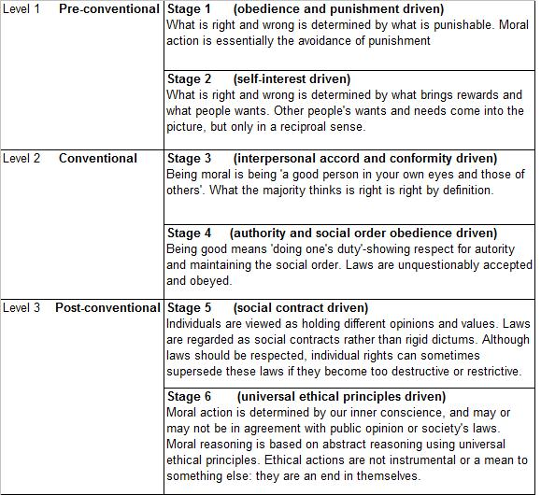

Erikson’s Theory of Psychosocial

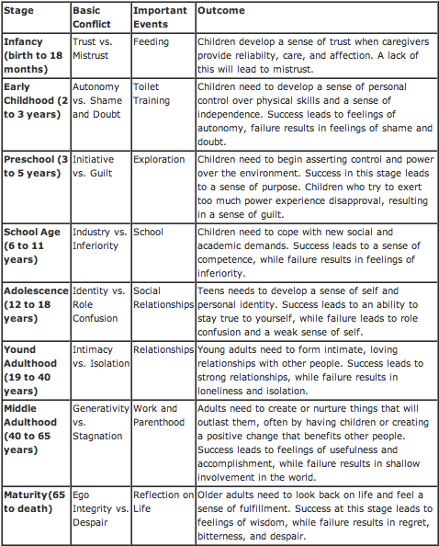
LIFE/VALUES/GOALS

As you think about your death and as you see your life now, try to answer the following:

- What three things would be said about your life if you died today?

- Given the likelihood that you will not die today, and have time left to change some things in your life, what three things would you most like to have said about you and your life?

- If someone were to witness a week of your life, what assumptions would that person make about your values?

- What values do you hold that are not evident from the way you live your life? What goals are important to you as you plan your life?

- What keeps you from achieving what you want for your life?

