Ch. 3:
Nature, Nurture and Human Diversity

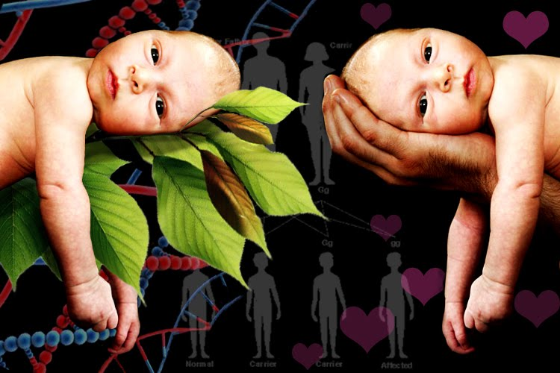

AP Psychology
Mrs. Wilson
Assignment | Due Date | Points | Points Earned
Read 95-101 |  | 0
Read 102-109 |  | 0
Read 110-113 |  | 0
Read 114-126 |  | 0
Read 126-136 |  | 0
Quiz (4) |  | 40
Key Terms |  | 20
Packet
Name ___________________________

Period _____
Key Terms and Figures

Terms

Behavior Genetics
DNA
Chromosomes
Genes
Genome
Twin Studies
Paternal Twins
Fraternal Twins
Adoption Studies
Temperament
Heritability
Interactions
Molecular Genetics

Evolutionary Psychologists
Natural Selection
Mutations
Gender
Culture
Norms
Individualism
Collectivism
Roles
Gender Roles
Gender Identity
Gender Typed
Gender Schema Theory

Similarities Questionnaire

Characteristic | Alike | Different
Politics
Music
Religion
Clothes
Jobs
Sports
Hobbies
Favorite Subject
Disliked Subject
Favorite Foods
Disliked Foods
Favorite Color
Sleeping Habits
Reading Tastes
Talents
Aversions
Chewing Gum
Toothpaste brand
Favorite Magazine
Favorite TV Show
Educational Interests
Special Talents
Pets
Family Members (names, ages, interests)
Habits
Personality Traits
Vacation – activities, preferences, etc.
Social Preferences (gregarious, introverted, etc.)
Handedness
Automobile Preference

Evolutionary Psychology

1. You are on a boat that overturns. It contains your 5-year-old and 1-year-old children (of the same sex). The boat sinks and you can save only one. Whom do you choose to save? Circle one:

5-year-old 1-year-old

2. That same boat (you are slow to learn lessons) contains your 40-year-old and 20-year-old children (both of the same sex). Neither can swim. As the boat sinks, whom do you choose to save? Circle one:

40-year-old 20-year-old

3. Would you rather marry (or have you married) someone older or younger than yourself? Circle one:

Older younger

4. Of the following six, which three are most important in the selection of your mate? Circle the answers:

a. good financial prospects
b. good looks
c. a caring and responsible personality
d. physical attractiveness
e. ambition and industriousness
f. an exciting personality

5. You and your spouse are the proud parents of a new child. The grandparents are ecstatic. Who do you think will be kinder to the child? Circle one:

the mother of the mother the mother of the father

6. Who will mourn more at the death of a child? Circle the answer in each pair:
a. father mother
b. parents of the father
c. parents of the mother
d. younger parents older parents

Source: B. Weiner. Psychoanalytic, ethological, and sociobiological theories: Mechanisms in biology. Human motivation:
Metaphors, theories, and research, p. 51. Copyright © 1992. Reprinted by permission of Sage Publications, Inc.

