Ch. 1:
Research Methods

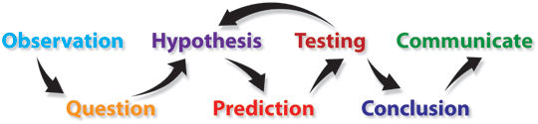

AP Psychology
Mrs. Wilson
Assignment | Due Date | Points | Points Earned
Read 19-24 |  | 0
Read 24-30 |  | 0
Read 30-35 |  | 0
Read 35-42 |  | 0
Read 42-44 |  | 0
Read 44-49 |  | 0
Quiz (4) |  | 40
Key Terms |  | 30
Packet
Observation Project

Name ___________________________

Period _____

Research Methods (8–10%)
Psychology is an empirical discipline. Psychologists develop knowledge by doing research. Research provides guidance for psychologists who develop theories to explain behavior and who apply theories to solve problems in behavior.

AP students in psychology should be able to do the following:

1. Describe the types of research with regard to purpose, strengths, and weaknesses.
a. experiments,
b. correlational studies,
c. survey research,
d. naturalistic observations,
e. cross-sectional studies,
f. longitudinal studies,
g. and case studies

2. For each research method, thoroughly describe how research design drives the reasonable conclusions that can be drawn (e.g., experiments are useful for determining cause and effect).

3. Describe, compare and contrast the following variables in experimental designs.
a. independent variables,
b. dependent variables,
c. confounding variables,
d. and control variables
e. Design your own experiment and provide examples of each.

4. Explain the difference between random assignment of participants to conditions in experiments and random selection of participants, primarily in correlational studies and surveys.

5. Predict the validity of behavioral explanations based on the quality of research design (e.g., confounding variables limit confidence in research conclusions).

6. Explain the purposes of descriptive statistics and inferential statistics.

7. Explain application of basic descriptive statistical concepts, including interpreting and constructing graphs and calculating simple descriptive statistics
— (e.g., measures of central tendency, standard deviation).

8. Explain the value of reliance on operational definitions and measurement in behavioral research.

9. Describe how ethical issues inform and constrain research practices.

10. List and describe each of the APA ethical guidelines for conduction research involving humans.

11. Compare and contrast the APA ethical guidelines of research involving human and animal subjects.

12. Describe how ethical and legal guidelines (e.g., those provided by the American Psychological Association, federal regulations, and local institutional review boards) protect research participants and promote sound ethical practice. Be sure to include the actual guidelines, too.

Observational Studies of Humans
Your task for this assignment is as follows.
- First, select one of the two research questions described below:

EITHER:
Lately there has been a great deal of interest in handedness--which people prefer to use to hold objects, use tools, etc. Along a similar line, one can ask about how people carry objects that are too large to fit into one hand. On a college campus, for example, people are often observed carrying piles of books and papers that far exceed a handful. How do people carry these objects? Is there any difference between men and women in how they carry books? Take a few minutes and note how people passing by carry their books. Are there a few basic styles? Summarize the carrying styles you see, define them, and then count how many men and women passing by you in a half hour's time use each of the styles that your have defined. Use the attached data sheet to record your observations.

OR:

There has also been a good deal of interest in communication differences between women and men. Part of communication is body language, including touching the person to whom one is talking. When mixed sex groups of people are talking in casual conversation (for example, in the dining hall or in the SAB), are men and women equally likely to touch each other? Or are they more likely only to touch members of the same sex? Take a few minutes to observe some groups of people talking, and see if you can identify who touches who. Then, record your observations for one half-hour, noting who initiates and who receives a touch in these groups in that time. You may need to make some decisions about what constitutes a group, what is a touch, and when to stop watching one group and begin watching another. Be sure to describe your decisions in your summary. Use the appropriate data sheet to record your observations.

- Then, conduct an observation of one half hour, in an attempt to answer the research question that you have chosen. Download the appropriate data sheet from our website (there is one for each of the two research questions):

- Finally, write up the results of your "study" in a short, one to two page summary. Think of this research summary as practice for a larger, more formal research paper, such as a senior thesis. As such, your summary should follow the natural progression of a research paper, though again, it need be no more than one page in length.

A true research paper has at minimum six basic parts:

I. Abstract. Following a title page with your name on it, the abstract is a brief paragraph summarizing the entire paper. That means it should include a sentence or two that summarizes the introduction, a sentence or two that summarizes the methods, a sentence or two that summarizes the results, and a sentence or two that summarizes the discussion. Ordinarily, it is best to write the abstract last, when you are certain of the content of your paper. Keep abstracts short and concise (usually less than 120 words). Here is an example:

The flap-nosed fribblewump (Ethologica morganii) was studied on a 2 ha field in southern New England during a 5-day period in February. Action patterns observed include three types of locomotion, 13 maintenance activities, six foraging and feeding patterns, four types of agonistic behavior and seven other patterns. The most notable discovery was that this species flies using the flaps on its nose as wings, whereas its close relatives use their nose flaps for burrowing.

II. An Introduction: In this section, you introduce the topic and explain the question that your study asks. Why did you conduct this investigation? An adequate introduction for this assignment might be only a few sentences long:

Ex. "This study was an investigation of .......... It was conducted as part of the requirements for an introductory psychology class at Wheaton College."
If you are very ambitious, you may look through your text book, search the internet, or visit the library for information related to the question that you have investigated. If so, the introduction is where you would discuss what is already known. Your task then would be to show the reader how what you did is a logical replication, extension, or progression from what is already known.

III. Methods: Describe in detail your procedure, your subjects, and any equipment that you used. Be sure to include the name of the observation technique that you employed, where and when you made your observations, and any operational definitions that you used.

IV. Results. Describe your results. How many of each case did you observe? Or, what percent of each case did you observe? How do all the cases compare? While you may use tables and graphs in a results section, you should still include a written description of your results.

V. Discussion. Discuss and interpret your results here. What do you think they mean? How do they answer the question that you set out to answer? How do they fail to do so? What improvements might be made to the study? What ideas or problems did you have while conducting it? You should also make an effort to compare your observations with those in the literature, pointing out where your observations confirm, dispute or add to existing reports.

APA Format Guidelines

General Guidelines:
- Margins: 1″ on all sides
- Font Size and Type: 12-pt. Serif style type like Currier or Times New Roman
- Line Spacing: Double-space throughout the entire paper.
- Spacing after Punctuation: Space once after commas, colons, and semicolons within sentences. Insert two spaces after punctuation ending sentences.
- Alignment: Flush left
- Paragraph Indentation: 5-7 spaces
- Pagination: The page number appears one inch from the right edge of the paper on the first line of every page.
- Running Head: The running head is a short title that appears at the top of the pages of a paper or published article. The running head is typed flush left (all uppercase) following "Running head:" at the top of all pages (including the title page). The running head should not exceed 50 characters, including punctuation and spacing.
- Active voice: As a general rule, use the active voice rather than passive.
Title Page Format:

- Pagination: The Title Page is page 1.
- Paper Title: Uppercase and lowercase letters, centered on the page.
- Author(s): Uppercase and lowercase letters, centered on the line following the title.
- Institutional affiliation: Uppercase and lowercase letters, centered on the line following the author(s).

Running Head: PERFECT APA FORMAT EXAMPLE 1

Wilson’s Awesomely Perfect APA

Format Example

Mrs. Wilson

Troy High School

Author’s Note

An author’s note is optional. It is a place to provide additional information about the
author’s departmental affiliation, acknowledgments of assistance or financial support, and a mailing
address for correspondence.
Most student papers do not require any notes of this nature.

Abstract

Immediately follows the title page, the abstract is a 100-150 word summary of your entire paper. It

Will be the only content on the entire page. Your paper itself will begin on the next page.
Body
- Title: The title of the paper is centered on the first line below the running head. As a level one heading, it should be bolded
- Introduction: Immediately after the title, provide an introduction to your topic. You do not need a specific heading for this section
- Headings: APA style provides Five levels of headings to help you organize the different sections of your paper. You will probably only use two or three.
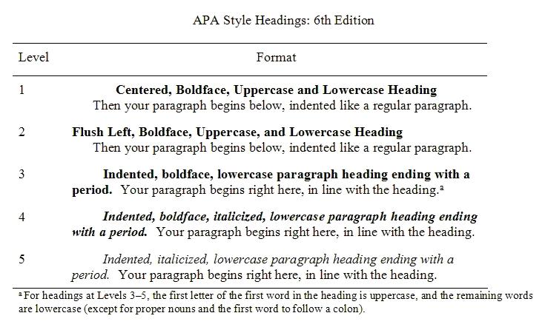

PERFECT APA FORMAT EXAMPLE 1

Title

The text of your paper starts here with the introduction

Methods
(Results and Discussion are the same)

Paragraph begins here… indent as usual for the first line

Subheadings for Major Sections

If you need them

Key Terms

Terms

Hindsight Bias
Overconfidence
Scientific Attitude
Critical Thinking
Scientific Method
Hypothesis
Theory
Operational Definitions
Replicate
Observation
Case Study
Survey
Wording Effects
False Consensus Effect
Population
Random Sample
Naturalistic Observation
Correlation
Scatterplot
r value
Positive and Negative Correlation
Correlation and Causation
Illusory Correlation
Experiment
Single and Double Blind Studies
Placebo Effect
Experimental Condition
Control Condition
Random Assignment
Independent Variable (IV)
Dependent Variable (DV)
Variance
Mean
Median
Mode
Range
Standard Deviation
Representative Sample
Statistical Significance
Ethics

The Need for Psychological Science

Common Sense Observations
Do you agree or disagree that these observations about human behavior in our presentation are generally true?

- ______ 2. ______ 3. ______ 4. ______ 5. ______ 6. ______
7. ______ 8. ______ 9. ______ 10. ______ 11. ______ 12. ______
13.______ 14. ______ 15. ______ 16. ______

Critical Thinking
Write down the 10 tools in our critical thinking “Baloney Detection Kit”

Applying Critical Thinking to Pseudoscience–

Wisconsin native Nancy Leider claims she was abducted by aliens who can communicate to her telepathically through an implant they placed in her head. Through this communication, the aliens have informed her of earth’s eminent destruction. Nibiru, or the Planet X is heading towards us, and the collision will result in our annihilation.

Pick any 3 of the questions from the Baloney tool kit and apply them to this claim.

Record your conclusions in your journal

Overview of Psych Scientific Research
Types
Basic –
Applied –
Lab –
Field –

Two Main Biases
Overconfidence Effect –
Confirmation Bias –

Category of Research | Purpose | Instruments | Strengths | Weaknesses
Descriptive | - Observe behavior  - Record | - Case study  - Survey  - Naturalistic Observation
Correlational | - Detect Relationships  - Predict effects when variables accompany one another | - Gather data from surveys and public records  - Scatterplots  - Statistical Computations  - R = +1 to -1
Experimental | - Explores cause and effect  - IV causes and effects DV  - Allows for the manipulation of variables | - Random assignment of subjects  - Experimental and control groups  - Placebo  - Controls  - Double and single blind studies

Creating A Living Frequency Distribution

Term | Definition in your own words | Give an example
Discrete Variable
Dichotomy
Trichotomy
Continuous Variable
Continuum
Measures of Central Tendency
Mode
Median
Mean
Measures of Variability
Range
Standard Deviation
Distribution
Histogram
Normal Curve
Skew
Outlier

