Chapters 10 & 11:
Thinking, Language, and Intelligence

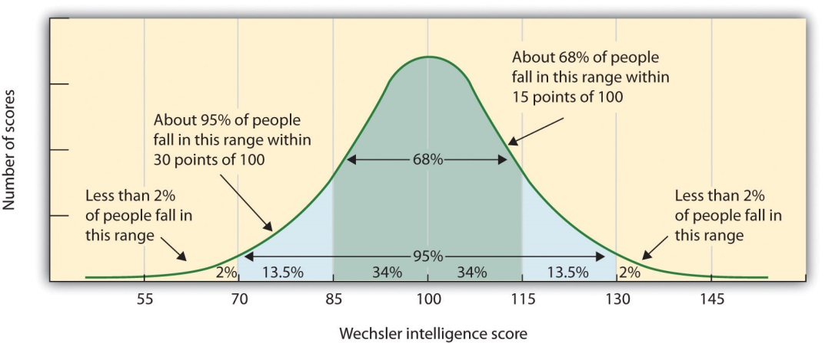

AP Psychology
Mrs. Wilson
Assignment | Due Date
Read 395-401
Read 401 - 409
Read 410 - 417
Read 418 - 422
Read 423 - 428
Read 431 - 442
Read 443 -449
Read 450 - 454
Read 454 - 466

Name___________________________

Period _____

Cognition (8–10%)

Incorporates material in chapters on Memory and Thinking and Language. Bold indicates concepts from Chapter 10 Thinking and Language

In this unit students learn how humans convert sensory input into kinds of information. They examine how humans learn, remember, and retrieve information. This part of the course also addresses problem solving, language, and creativity.

AP students in psychology should be able to do the following:
- Compare and contrast various cognitive processes:
  - effortful versus automatic processing;
  - deep versus shallow processing;
  - focused versus divided attention.
- Describe and differentiate psychological and physiological systems of memory
  - Short-term memory
  - Long-term memory
  - Implicit memory
  - Explicit memory
  - Long-term potentiation
  - Stress hormones and impact on memory
  - Role of hippocampus and cerebellum in memory formation
  - Moods and memory
- Thoroughly explain effective encoding, storage, and retrieval (use pictures in your explanation).
- Discuss construction of memories (include an example of each).
  - Misinformation and imagination effect
  - Source amnesia
  - Eyewitness testimony
  - Repression
- Describe strategies for memory improvement.
- Explain how the following factors converge to facilitate acquisition, development, and use of language.
  - Biological factors,
  - Cognitive factors,
  - and cultural factors
- Identify problem-solving strategies as well as factors that influence their effectiveness.
- List the characteristics of creative thought and creative thinkers.
- Make a chart to identify the major figures in the psychology of cognition using the following columns (Who, What, When, Where and Why)
  - Noam Chomsky,
  - Hermann Ebbinghaus,
  - Wolfgang Köhler,
  - Elizabeth Loftus,
  - George A. Miller

Testing and Individual Differences (5–7%)

An understanding of intelligence and assessment of individual differences is highlighted in this portion of the course. Students must understand issues related to test construction and fair use.

AP students in psychology should be able to do the following:
- Define intelligence and list characteristics of how psychologists measure intelligence:
  - abstract versus verbal measures;
  - speed of processing.
- Explain how culture influences the definition of intelligence.
- Compare and contrast historic and contemporary theories of intelligence
  - Charles Spearman’s theory
  - L.L. Thurstone’s theory
  - R.B. Cattell’s theory
  - Howard Gardner’s theory
  - Robert Sternberg’s theory
  - Daniel Goleman’s theory
- Explain how psychologists design tests, including standardization strategies and other techniques to establish reliability and validity.
- Explain the meaning of scores in terms of the normal curve.
- Describe relevant labels related to intelligence testing
  - gifted,
  - cognitively disabled,
- Debate the appropriate testing practices, particularly in relation to culture-fair test uses.
- Identify the major figures in testing and individual differences using the following columns (Who, What, When, Where and Why)
  - Alfred Binet,
  - Francis Galton,
  - Howard Gardner,
  - Charles Spearman,
  - Robert Sternberg,
  - Lewis Terman,
  - David Wechsler

Key Terms and Figures

Terms

- Cognition
- Concept
- Prototype
- Algorithm
- Heuristic
- Insight
- Confirmation bias
- Fixation
- Mental set
- Functional fixedness
- Representativeness heuristic
- Availability heuristic
- Overconfidence
- Framing
- Belief bias
- Belief perseverance
- Language
- Phonemes
- Morpheme
- Grammar
- Semantics
- Syntax
- Developmental stages of language
  - Babbling stage
  - One-word stage
  - Two-word stage
  - Telegraphic speech
- Critical Period
- Linguistic determinism
- Intelligence
- Factor analysis
- General intelligence
- Multiple intelligences
- Savant syndrome
- Triarchic theory
- Emotional intelligence
- Creativity
- Mental age
- Stanford- Binet
- Aptitude test
- Achievement test
- Standardization
- Normal curve
- Reliability
- Validity
- Content validity
- Criterion
- Predictive validity
- Mental retardation
- Down Syndrome
- Stereotype threat

Names
- Noam Chomsky
- Alfred Binet,
- Francis Galton,
- Howard Gardner,
- Charles Spearman,
- Robert Sternberg,
- Lewis Terman,
- David Wechsler

KEY TERMS DUE AT TEST

For each conceptual term:

Write the concept name in RED
Write the definition in BLACK
Write a sentence or two in your own words illustrating or applying the term in BLUE

Example

PSYCHOLOGY – the scientific study of mental processes and behavior

Psychology uses scientific research to understand why we act, think, and feel the way we do. It also studies what is happening when things go wrong and how to help people who are ill.

For each important figure in Psychology:

Write the name in RED
Write when and where they worked and what they did in BLACK
Write why they are significant in BLUE

Example

SOCRATES - (469-399) Ancient Greek philosopher. Teacher of Plato and Aristotle. Plato believed
that the mind and body was separate and that we were born with innate knowledge within us.

His teachings on mind and body influenced thinker like Descartes to once again consider how the mind and body related to each other, leading to the development of the concept of dualism. His thoughts about innate knowledge also sparked continued discussion of the nature/nurture debate

Problem Solving

- The Buddest Monk Problem

Exactly at sunrise one morning, a Buddhist monk set out to climb a tall mountain. The narrow path was not more than a foot or two wide, and it wound around the mountain to a beautiful, glittering temple at the mountain peak. The monk climbed the path at varying rates of speed. He stopped many times along the way to rest and to eat the fruit he carried with him. He reached the temple just before sunset. At the temple, he fasted and meditated for several days. Then he began his journey back along the same path, starting at sunrise and walking, as before, at variable speeds with many stops along the way. However, his average speed going down the hill was greater than his average climbing speed.

Prove that there must be a spot along the path that the monk will pass on both trips at exactly the same time of day.

Source: Reprinted by permission of PFD on behalf of The Estate of Arthur Koestler, A. © 1964.

2. Husbands and Wives Problem

Three men—Fred, Ed, and Ted—are married to Joan, Sally, and Vickie, but not necessarily in that order. Joan, who is Ed’s sister, lives in Detroit. Fred dislikes animals. Ed weighs more than the man who is married to Vickie. The man married to Sally breeds Siamese cats as a hobby. Fred commutes over 200 hours a year from his home in Ann Arbor to his job in Detroit. Match up the men with the women they married.

Source: Whimbey, A. & Lochhead, J. (1982). Problem solving and comprehension: A short course in analytic reasoning (p. 67). Philadelphia: Franklin Institute Press.

3. The Hobbits-and-Orcs Problem

Three Hobbits and three Orcs arrive at a river bank, and they all wish to cross onto the other side. Fortunately, there is a boat, but unfortunately, the boat can only hold two creatures at one time. Also, there is another problem. Orcs are vicious creatures, and whenever there are more Orcs than Hobbits on one side of the river, the Orcs will immediately attack the Hobbits and eat them up. Consequently, you should be certain that you never leave more Orcs than Hobbits on any river bank. How should the problem be solved? (Note that the Orcs, though vicious, can be trusted to bring the boat back!)

Source: Reprinted from Cognitive Psychology, 6, J. G. Greeno, Hobbits and Orcs: Acquisition of a sequential concept, pp. 270–272, copyright © 1974, with permission from Elsevier.

4. Truth tellers and Liars

You are visiting a strange country in which there are just two kinds of people—truth tellers and liars. Truth tellers always tell the truth and liars always lie. You hail the first two people you meet and say, “Are you truth tellers or liars?” The first person mumbles something you can’t hear. The second says, “He says he is a truth teller. He is a truth teller and so am I.” Can you trust the directions that these two may give you?

Source: Reprinted by permission of Lawrence Erlbaum Associates, Inc., and the author from Hayes, J. R. (1981). The complete problem solver, p. 20.

